Abstract:

With the increased number of events being held in the countries there is an increased need for a way to plan the events in a more organised way that gives the ability for all the users to check the dates of other events in order to not cause any conflicts in schedule. The website does provide this need.

1. Requirements:
2. The website will have a registration/login page that takes the user to the currently planned events.
3. The 2nd page will be a list of all the current planned events with a summary of each event in which you can either create a new event, or view all the details of the current events.
4. Using the create a new event link leads to the creation page which will have a validation for the inputs for the event.
5. Pressing the details link will lead to the page containing the details of the event based on the status of the user, if the user is the owner of the event the page will contain a link to update and a link to delete said event, if not then the page will only contain the details of the event.
6. The update page will have a new form to update the event which will have the same validation as the create a new event.

2. Wireframe:

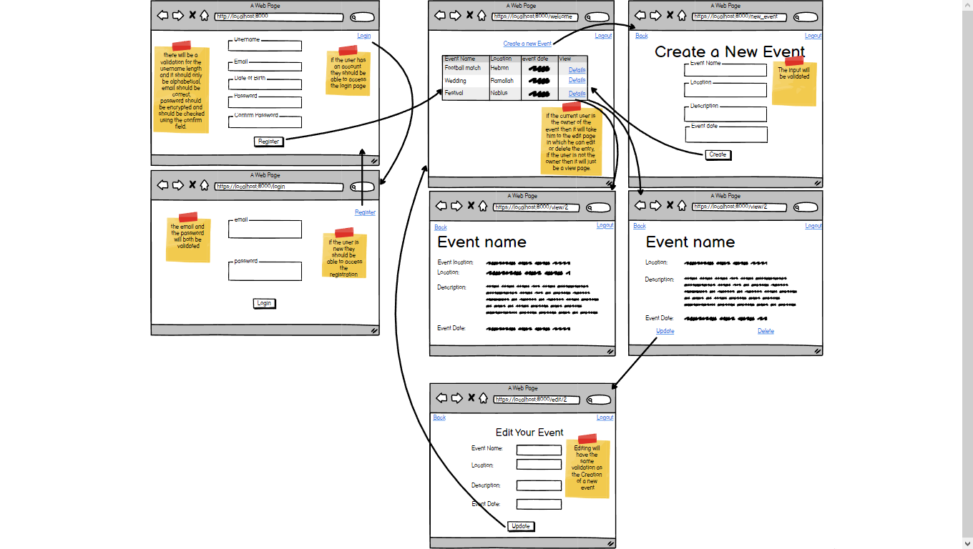

3. ERD:

